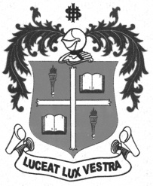
LOYOLA COLLEGE (AUTONOMOUS), CHENNAI – 600 034
M.A. DEGREE EXAMINATION - TAMIL LITERATURE
FIRST SEMESTER – APRIL 2012

TL 1802 - HISTORY OF TAMILNADU & CULTURE-I

Date : 30-04-2012 Dept. No. Max. : 100 Marks

Time : 9:00 - 12:00



 x=
- 
- 
- 
- 
- 
- 



 x=
- 
- 
- 
- 
- 
- 



 x=
- 
- 
- 
- 


